**Project Design Phase – I**

**Solution Architecture**

|  |  |
| --- | --- |
| Team ID | PNT2022TMID23657 |
| Project Name | Project – Plasma Donor Application |
| Maximum Marks | 4 Marks |

**Solution Architecture – Donor :**

Fill the

Register

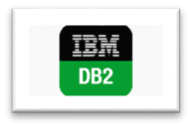

Login

registration

Upload Certificates

First time login

Ask with chatbot

E

-

mail alert

Reject

Send confirmation

details to the patient

Donor

form

Queries Request of Plasma

Accept

**Solution Architecture – Patient :**

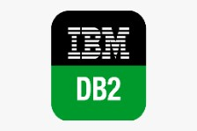

Patient

Register

Login



Fill the

requesting

form

Queries

Ask with chatbot

E

-

mail alert to donors

Receiving the accepting

message from the

donor